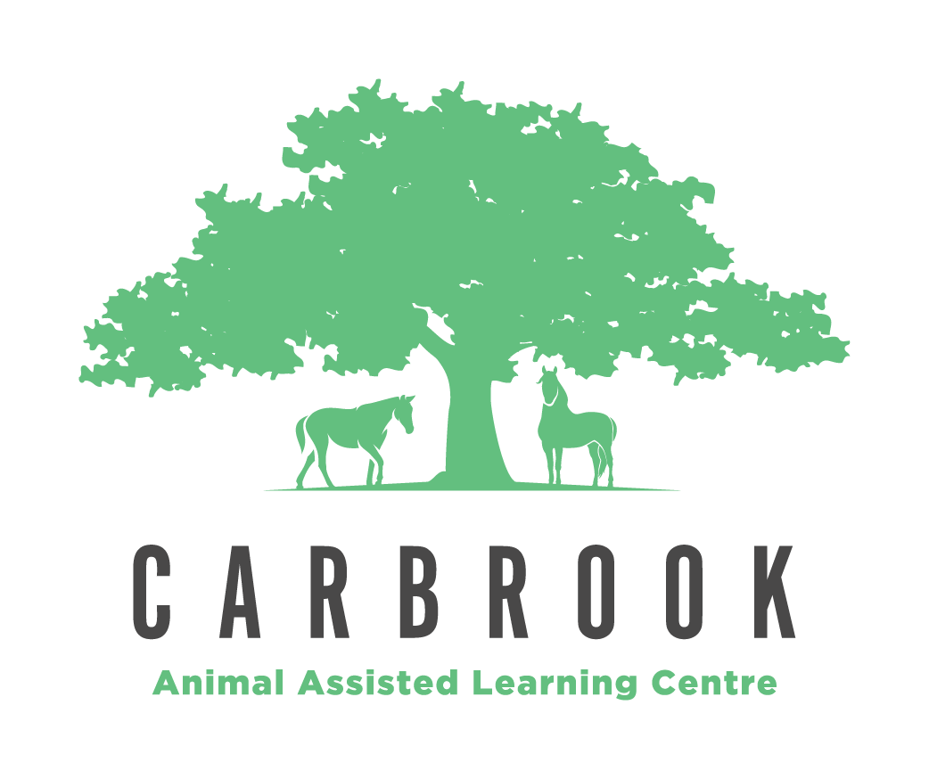

Privacy Policy

Privacy Policy 2.0
Purpose: | Carbrook Animal Assisted Learning Centre (Carbrook Centre/ the school) is bound by the Australian Privacy Principles contained in the Commonwealth Privacy Act. This statement outlines the privacy policy of the school and describes how the school uses and manages personal information provided to or collected by it.
Scope: | The policy applies to board members, employers, employees, volunteers, parents/guardians and students, contractors, and people visiting the school site; and describes the type of information the school collects, how the information is handled, how and to whom the information is disclosed, and how the information may be accessed.
References: | - Australian Privacy Principles  - Privacy Act 1988 (Cth)  - Carbrook Centre Child Protection Policy  - Carbrook Centre Supporting Students with Disabilities Policy
Status: | Approved
Supersedes: | Version 1.0
Authorised by: | Board | Date of Authorisation:  18 January 2021
Review Date: | December 2020 | Next Review Date:  September 2021
Policy Owner: | Transformed Futures Ltd.

Exception in Relation to Employee Records:
Under the Privacy Act 1988 (Cth) (Privacy Act), the Australian Privacy Principles do not apply to an employee record held by the employing entity. As a result, this Privacy Policy does not apply to Carbrook Centre’s treatment of an employee record, where the treatment is directly related to a current or former employment relationship between Carbrook Centre and the employee.

Policy
This Privacy Policy sets out how Carbrook Centre manages personal information provided to or collected by it. Carbrook Centre is bound by the Australian Privacy Principles contained in the Privacy Act. Carbrook Centre may, from time to time, review and update this Privacy Policy to take account of new laws and technology, changes to operations and practices and to make sure it remains appropriate to the changing school environment.

What kinds of personal information does the School collect and how does the School collect it?
The type of information Carbrook Centre collects and holds includes (but is not limited to) personal information, including health and other sensitive information, about:
- students and parents and/or guardians ('Parents') before, during and after the course of a student's enrolment at the School:
  - name, contact details (including next of kin), date of birth, gender, language background, previous school and religion;
  - parents' education, occupation and language background;
  - medical information (e.g. details of disability and/or allergies, absence notes, medical reports and names of doctors);
  - conduct and complaint records, or other behaviour notes, and school reports; information about referrals to government welfare agencies;
  - counselling reports;
  - health fund details and Medicare number;
  - any court orders;
  - volunteering information; and
  - photos and videos at school events.
- job applicants, staff members, volunteers and contractors:
  - name, contact details (including next of kin), date of birth, and religion;
  - information on job application;
  - professional development history;
  - salary and payment information, including superannuation details;
  - medical information (e.g. details of disability and/or allergies, and medical certificates);
  - complaint records and investigation reports;
  - leave details;
  - photos and videos at school events;
  - workplace surveillance information;
  - work emails and private emails (when using work email address) and Internet browsing history
- other people who come into contact with the school including name and contact details and any other information necessary for the particular contact with the school.

Personal Information you provide:
Carbrook Centre will generally collect personal information held about an individual by way of forms filled out by parents or students, face-to-face meetings and interviews, emails and telephone calls. On occasions people other than parents and students provide personal information.

Personal Information provided by other people:
In some circumstances the Carbrook Centre may be provided with personal information about an individual from a third party, for example a report provided by a medical professional or a reference from another school.

How will the School use the personal information you provide?
Carbrook Centre will use personal information it collects from you for the primary purpose of collection, and for such other secondary purposes that are related to the primary purpose of collection and reasonably expected by you, or to which you have consented.

Students and Parents
In relation to personal information of students and parents, Carbrook Centre’s primary purpose of collection is to enable school to provide schooling to students enrolled at the school, exercise its duty of care, and perform necessary associated administrative activities, which will enable students to take part in all the activities of the school. This includes satisfying the needs of parents, the needs of the students and the needs of the school throughout the whole period the student is enrolled at the school.
The purposes for which Carbrook Centre uses personal information of students and parents include:
- to keep parents informed about matters related to their child's schooling, through correspondence, newsletters and magazines
- day-to-day administration
- looking after student's educational, social and medical wellbeing
- seeking donations and marketing
- to satisfy legal obligations and allow the school to discharge its duty of care.
In some cases where Carbrook Centre requests personal information about a student or parent, if the information requested is not provided, the Carbrook Centre may not be able to enrol or continue the enrolment of the student or permit the student to take part in a particular activity.
On occasions information such as academic and sporting achievements, student activities and similar news is published in newsletters or on our website this may include photographs and videos of student activities such as special events and excursions. Carbrook Centre will obtain permissions [annually] from the student's parent or guardian (and from the student if appropriate) if we would like to include such photographs or videos [or other identifying material] in our promotional material or otherwise make this material available to the public such as on the internet.

Job applicants, Staff Members and Contractors
In relation to personal information of job applicants, staff members and contractors, Carbrook Centre’s primary purpose of collection is to assess and (if successful) to engage the applicant, staff member or contractor, as the case may be.
The purposes for which Carbrook Centre uses personal information of job applicants, staff members and contractors include:
- in administering the individual's employment or contract, as the case may be
- for insurance purposes
- seeking donations and marketing for the School
- to satisfy the School's legal obligations, for example, in relation to child protection legislation.

Volunteers
The School also obtains personal information about volunteers who assist the Carbrook Centre in its functions or conduct associated activities, such as alumni associations, to enable the Carbrook Centre and the volunteers to work together.

Marketing and Fundraising
The Centre treats marketing and seeking donations for the future growth and development of the school as an important part of ensuring that Carbrook Centre continues to provide a quality learning environment in which both students and staff thrive. Personal information held by Carbrook Centre may be disclosed to organisations that assist in the school's fundraising.
Parents, staff, contractors and other members of the wider school community may from time to time receive fundraising information. School publications, like newsletters which include personal information, may be used for marketing purposes.
If you would like to opt-out of direct marketing please contact the Principal.

Who might the School disclose Personal Information to and store your information with?

Carbrook Centre may disclose personal information, including sensitive information, held about an individual for educational, legal, administrative, marketing and support purposes. This may include to:
- another school or staff at another school
- government departments (including for policy and funding purposes)
- medical practitioners
- people providing educational, support and health services to the School, including specialist visiting teachers, [sports] coaches, volunteers, counsellors and providers of learning and assessment tools
- assessment and educational authorities, including the Australian Curriculum, Assessment and Reporting Authority (ACARA) and NAPLAN Test Administration Authorities (who will disclose it to the entity that manages the online platform for NAPLAN)
- people providing administrative and financial services to Carbrook Centre;
- recipients of school publications, such as newsletters
- students' parents or guardians
- anyone you authorise Carbrook Centre to disclose information to
- anyone to whom we are required or authorised to disclose the information to by law, including child protection laws.

Sending and Storing Information Overseas.
Carbrook Centre may use online or 'cloud' service providers to store personal information and to provide services to Carbrook Centre that involve the use of personal information, such as services relating to email, instant messaging and education and assessment applications. Some limited personal information may also be provided to these service providers to enable them to authenticate users that access their services.
All school data is collected, managed and retained in accordance with the Education (Accreditation of Non-State Schools) Regulation 2017 and Australian Privacy Principles and associated governing bodies. The school’s core data storage and management systems reside within an Australian based Microsoft Office 365 cloud tenant.

Sensitive Information
In referring to 'sensitive information', Carbrook Centre means: information relating to a person's racial or ethnic origin, political opinions, religion, trade union or other professional or trade association membership, philosophical beliefs, sexual orientation or practices or criminal record, that is also personal information; health information and biometric information about an individual.
Sensitive information will be used and disclosed only for the purpose for which it was provided or a directly related secondary purpose, unless you agree otherwise, or the use or disclosure of the sensitive information is required by law.

Management and Security of Personal Information
Staff are required to respect the confidentiality of students' and parents' personal information and the privacy of individuals. Carbrook Centre has in place steps to protect the personal information Carbrook Centre holds from misuse, interference and loss, unauthorised access, modification or disclosure by use of various methods including locked storage of paper records and password access rights to computerised records.

Data Breaches
It will be deemed that an ‘eligible data breach’ has occurred if:
- there has been unauthorised access to, or unauthorised disclosure of, personal information about one or more individuals (the affected individuals)
- a reasonable person would conclude there is a likelihood of serious harm to any affected individuals as a result
- the information is lost in circumstances where:
  - unauthorised access to, or unauthorised disclosure of, the information is likely to occur
  - assuming unauthorised access to, or unauthorised disclosure of, the information was to occur, a reasonable person would conclude that it would be likely to result in serious harm to the affected individuals.
Serious harm may include serious physical, psychological, emotional, economic and financial harm, as well as serious harm to reputation.
What must the school do in the event of an ‘eligible data breach’?
If Carbrook Centre suspects that an eligible data breach has occurred, it will carry out a reasonable and expedient assessment/investigation within 30 days.
If such an assessment/investigation indicates there are reasonable grounds to believe an eligible data breach has occurred, then Carbrook Centre will be required to lodge a statement to the Privacy Commissioner (Commissioner). Where practical to do so, the school entity will also notify the affected individuals. If it is not practicable to notify the affected individuals, Carbrook Centre will publish a copy of the statement on its website, or publicise it in another manner.
Exception to notification obligation
An exception to the requirement to notify will exist if there is a data breach and immediate remedial action is taken, and as a result of that action:
  - there is no unauthorised access to, or unauthorised disclosure of, the information
  - there is no serious harm to affected individuals, and as a result of the remedial action, a reasonable person would conclude the breach is not likely to result in serious harm.

Access and Correction of Personal Information
Under the Privacy Act, an individual has the right to seek and obtain access to any personal information which Carbrook Centre holds about them and to advise Carbrook Centre of any perceived inaccuracy. There are some exceptions to this right set out in the Act. Students will generally be able to access and update their personal information through their parents, but older students may seek access and correction themselves.
To make a request to access or to update any personal information Carbrook Centre holds about you or your child, please contact the Principal in writing. Carbrook Centre may require you to verify your identity and specify what information you require. Carbrook Centre may charge a fee to cover the cost of verifying your application and locating, retrieving, reviewing and copying any material requested. If the information sought is extensive, Carbrook Centre will advise the likely cost in advance. If we cannot provide you with access to that information, we will provide you with written notice explaining the reasons for refusal.
Carbrook Centre will take reasonable steps to ensure that any personal information is accurate, up to date, complete, relevant, and not misleading.

Consent and Rights of Access to the Personal Information of Students
Carbrook Centre respects every parent's right to make decisions concerning their child's education. Generally, Carbrook Centre will refer any requests for consent and notices in relation to the personal information of a student to the student's parents. Carbrook Centre will treat consent given by parents as consent given on behalf of the student and notice to parents will act as notice given to the student.
As mentioned above, parents may seek access to personal information held by Carbrook Centre about them or their child by contacting the Principal. However, there will be occasions when access is denied. Such occasions would include where release of the information would have an unreasonable impact on the privacy of others, or where the release may result in a breach of Carbrook Centre’s duty of care to a student.
Carbrook Centre may, at its discretion, on the request of a student grant that student access to information held by Carbrook Centre about them or allow a student to give or withhold consent to the use of their personal information, independently of their parents. This would normally be done only when the maturity of the student and/or the student's personal circumstances warrant it.

Enquiries and Complaints
If you would like further information about the way Carbrook Centre manages the personal information it holds or wish to make a complaint about Carbrook Centre’s breach of the Australian Privacy Principles please contact the Principal. Carbrook Centre will investigate any complaint and will notify you of the making of a decision in relation to your complaint as soon as is practicable after it has been made.

APPENDIX 1

Standard Collection Notice
1 The School collects personal information, including sensitive information about students and parents or guardians before and during the course of a student's enrolment at the School. This may be in writing or in the course of conversations. The primary purpose of collecting this information is to enable the School to provide schooling to students enrolled at the school, exercise its duty of care, engage in marketing/fundraising and perform necessary associated administrative activities, which will enable students to take part in all the activities of the School.
2. Some of the information we collect is to satisfy the School's legal obligations, particularly to enable the School to discharge its duty of care.
3. Laws governing or relating to the operation of a school require certain information to be collected and disclosed. These include relevant Education Acts, and Public Health and Child Protection laws.
4. Health information about students is sensitive information within the terms of the Australian Privacy Principles (APPs) under the Privacy Act 1988. We may ask you to provide medical reports about students from time to time.
5. The School may disclose personal and sensitive information for educational, legal, administrative, marketing and support purposes. This may include to:
- other schools and teachers at those schools;
- government departments (including for policy and funding purposes);
- Independent Schools Queensland, Education Queensland, and other projects related to Carbrook Centre
- medical practitioners;
- people providing educational, support and health services to the School, including specialist visiting teachers, coaches, volunteers, and counsellors;
- providers of learning and assessment tools;
- assessment and educational authorities, including the Australian Curriculum, Assessment and Reporting Authority (ACARA) and NAPLAN Test Administration Authorities (who will disclose it to the entity that manages the online platform for NAPLAN);
- people providing administrative and financial services to the School;
- anyone you authorise the School to disclose information to; and
- anyone to whom the School is required or authorised by law, including child protection laws, to disclose the information.
6. Personal information collected from students is regularly disclosed to their parents or guardians.
7. The School may use online or 'cloud' service providers to store personal information and to provide services to the School that involve the use of personal information, such as services relating to email, instant messaging and education and assessment applications. Some limited personal information may also be provided to these service providers to enable them to authenticate users that access their services. This personal information may reside on a cloud service provider's servers which may be situated outside Australia.
8. The School's Privacy Policy, accessible on the School's website, sets out how parents or students may seek access to and correction of their personal information which the School has collected and holds. However, access may be refused in certain circumstances such as where access would have an unreasonable impact on the privacy of others, where access may result in a breach of the School's duty of care to a student, or where students have provided information in confidence. Any refusal will be notified in writing with reasons if appropriate.
9. The School's Privacy Policy also sets out how parents and students can make a complaint about a breach of the APPs and how the complaint will be handled.
10. The School may engage in fundraising activities. Information received from you may be used to make an appeal to you. It may also be disclosed to organisations that assist in the School's fundraising activities solely for that purpose. We will not disclose your personal information to third parties for their own marketing purposes without your consent.
11. On occasions information such as academic and sporting achievements, student activities and similar news is published in School newsletters and magazines, on our intranet [and on our website] this may include photographs and videos of student activities such as sporting events, school camps and school excursions. The School will obtain permissions from the student's parent or guardian (and from the student if appropriate) if we would like to include such photographs or videos or other identifying material in our promotional material or otherwise make this material available to the public such as on the internet.
12. The school will seek specific consent to include students' and students' parents' contact details in a class list or School directory.
13.If you provide the School with the personal information of others, such as doctors or emergency contacts, we encourage you to inform them that you are disclosing that information to the School and why.

APPENDIX 2

Alumni Association Collection Notice
1. Our Alumni association may collect personal information about you from time to time. The primary purpose of collecting this information is to enable us to inform you about our activities and the activities of the school and to keep alumni members informed about other members.
2. We must have the information referred to above to enable us to continue your membership of our Alumni association.
3. As you know, from time to time we engage in fundraising activities. The information received from you may be used to make an appeal to you. It may also be used by Carbrook Centre to assist in its fundraising activities. If you do not agree to this, please advise the school.
4. Our Alumni association may publish details about you in our Alumni publication and our/the School's website. If you do not agree to this, please advise the school.
5. The School's Privacy Policy, accessible on the School's website, contains details of how you may seek access to and correction of your personal information which the School has collected and holds, and how you may complain about a breach of the Australian Privacy Principles.
6. The School may use online or 'cloud' service providers to store personal information and to provide services to the School that involve the use of personal information, such as email services. Some limited personal information may also be provided to these service providers to enable them to authenticate users that access their services. This personal information may reside on a cloud service provider's servers which may be situated outside Australia.
7. If you provide us with the personal information of others, we encourage you to inform them that you are disclosing that information to the School and why.

APPENDIX 3

Employment Collection Notice
1. In applying for this position, you will be providing Carbrook Centre with personal information.
2. If you provide us with personal information, for example, your name and address or information contained on your resume, we will collect the information in order to assess your application for employment. We may keep this information on file if your application is unsuccessful in case another position becomes available.
3. Carbrook Centre’s Privacy Policy, accessible on the School's website, contains details of how you may complain about a breach of the Australian Privacy Principles and how you may seek access to and correction of your personal information which the School has collected and holds. However, access may be refused in certain circumstances such as where access would have an unreasonable impact on the privacy of others. Any refusal will be notified in writing with reasons if appropriate.
4. We will not disclose this information to a third party without your consent unless otherwise permitted.
5. We may be required to conduct a criminal record check or collect information including whether you are or have been the subject of an Apprehended Violence Order and certain criminal offences under relevant Child Protection legislation. We may also collect personal information about you in accordance with these laws.
6. The School may use online or 'cloud' service providers to store personal information and to provide services to the School that involve the use of personal information, such as email services. Some limited personal information may also be provided to these service providers to enable them to authenticate users that access their services. This personal information may reside on a cloud service provider's servers which may be situated outside Australia.
7. If you provide us with the personal information of others, we encourage you to inform them that you are disclosing that information to the School and why.

APPENDIX 4

Contractor/Volunteer Collection Notice
1. In offering, applying or agreeing to provide services to the School, you will be providing [name of School] with personal information.
2. If you provide us with personal information, for example your name and address or information contained on your resume, we will collect the information in order to assess your application. We may also make notes and prepare a confidential report in respect of your application.
3. You agree that we may store this information for future reference.
4. The School's Privacy Policy, accessible on the School's website, contains details of how you may complain about a breach of the Australian Privacy Principles and how you may seek access to and correction of your personal information which the School has collected and holds. However, access may be refused in certain circumstances such as where access would have an unreasonable impact on the privacy of others. Any refusal will be notified in writing with reasons if appropriate.
5. We will not disclose this information to a third party without your consent unless otherwise permitted to.
6. We may be required to conduct a criminal record check or collect information including whether you are or have been the subject of an Apprehended Violence Order and certain criminal offences under relevant Child Protection legislation. We may also collect other personal information about you in accordance with these laws.
7. The School may use online or 'cloud' service providers to store personal information and to provide services to the School that involve the use of personal information, such as services relating to email, instant messaging and education and assessment applications. Some limited personal information may also be provided to these service providers to enable them to authenticate users that access their services. This personal information may reside on a cloud service provider's servers which may be situated outside Australia.
8. If you provide us with the personal information of others, we encourage you to inform them that you are disclosing that information to the School and why.

